CST2355 - Database Systems

Assignment #2: Data Model and Design [15%]

This assignment relates to the following Course Learning Requirements:
CLR 2 - Develop Advanced Database Design and Normalization

adhere to the Academic Integrity policy - no sharing, no copying, no group work
provide ONLY your own work.

Background
You work for a small Canadian e-commerce business. They’re moving their data on-site and will manage that data using a new database. The vendor sent you two extracts of the data in the from of a spreadsheet. These are data dumps from the existing off-site system. The spreadsheet includes --
- Directory data
- Sales data
You will take this denormalized data and normalize it using Data Modeler and SQL Developer.

Pre-Assignment Instructions
1 -- Read Modules 4, 5, 6 and 7 on Brightspace
2 -- Review the assignment support videos in the Additional Resources folder on Brightspace
3 -- Confirm Oracle Database, Data Modeler, SQL Developer, SQLPLUS are installed

4 -- Review the scripts provided with this assignment

5 -- Use the ASSIGN_2 user. Create the user if it doesn’t exist.

Embed all screenshots in the document where requested.
For full marks screenshots must have formatted output and complete showing ONLY the information requested. Include multiple screenshots if needed.Clear your screen using the CLEAR SCREEN command and use the CST2355_A2_Format.SQL script to beautify your query results.

Instructions
SQLPLUS and SQL Developer each have their own connection to the database. They cannot see each other’s changes without you running COMMIT. If either tool hangs, try running COMMIT in both tools. If hanging still occurs, close both tools and reopen them.

When designing a database from an extract, your first step is to move the files to tables in your database. This allows you massage the input data before its imported into your new destinations tables. Extracts come in all forms. For this assignment you will be importing CSV files. Before you do the import, you need to ensure the CSV files are properly prepared.

1 -- Download all files from the submission folder. Open CST2355_A2_DATA.XLS and save each tab to a .CSV. For each .CSV, make the following updates using a spreadsheet app.
- Delete the columns G, H, I, J, K in both files
- Delete the blank rows immediately after the last visible row for each file
- Do not clear. Use Delete.

Open each .CSV using a text editor to confirm each .CSV is ready for import. A .CSV file is ready when there are --
- no comma pairs (,,)
- no commas at the end of each line

Import each spreadsheet into the database using Data Import Wizard in SQL Developer. Do not change the defaults in the data import wizard screens. Name each new table ZZZ_DIRECTORY and ZZZ_SALES respectfully. Double check each table’s data using SQL Developer.

Go to SQLPLUS., Clear your screen. Type a comment line that includes your name, student number, and today’s date. Then run the following script. (You should receive a single table row from each SELECT).

SET LINESIZE 200
COLUMN Address FORMAT A10
COLUMN CustomerName FORMAT A10
COLUMN ProductName FORMAT A10
SELECT * FROM (SELECT ROWNUM AS X, Y.* FROM ZZZ_DIRECTORY Y) WHERE X >= 60;
SELECT * FROM (SELECT ROWNUM AS X, Y.* FROM ZZZ_SALES Y) WHERE X >= 100;

Provide a screenshots from SQLPLUS of your comment, script and its output results.

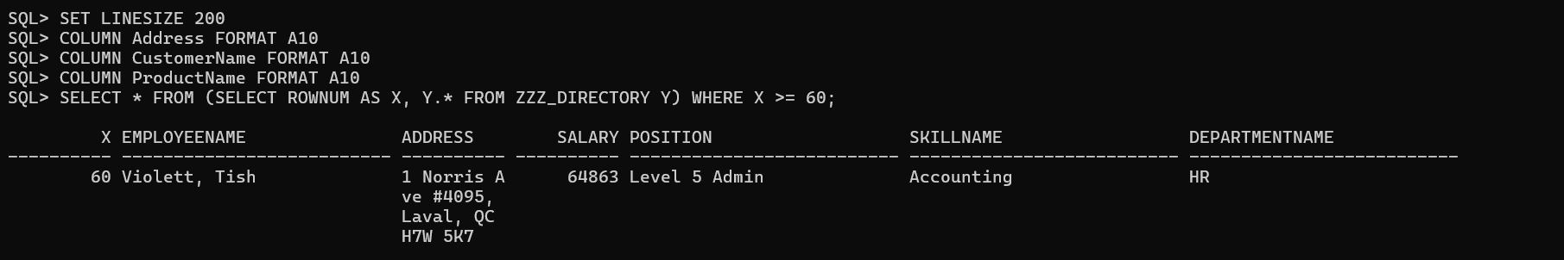
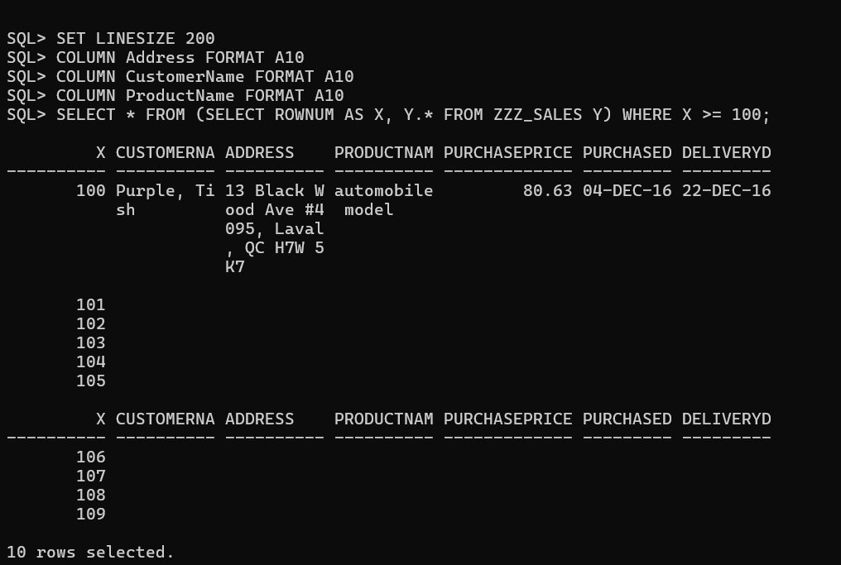

2 -- Create a new script that formats the specified columns in ZZZ_DIRECTORY and ZZZ_SALES into UPPER CASE and Proper Case. With the UPDATE statement use --
UPPER() to update DepartmentName to put into upper case
INITCAP() to update Position to put into proper case
LOWER() to update SkillName to put into lower case
Refer to https://www.oracletutorial.com/oracle-string-functions/oracle-initcap/ for examples.

Save your new script as your name and step number. Go to SQLPLUS and run your script using the @ command. Run CST2355_A2_Format.SQL using the @ command. Clear your screen.

Type a comment line that includes your name, student number, and today’s date. Then run the following statements.
SELECT DepartmentName, Position, SkillName
FROM ZZZ_DIRECTORY WHERE ROWNUM <= 30;

Provide screenshots from SQLPLUS of your script being ran using @, your comment, SELECTs, and formatted output results.
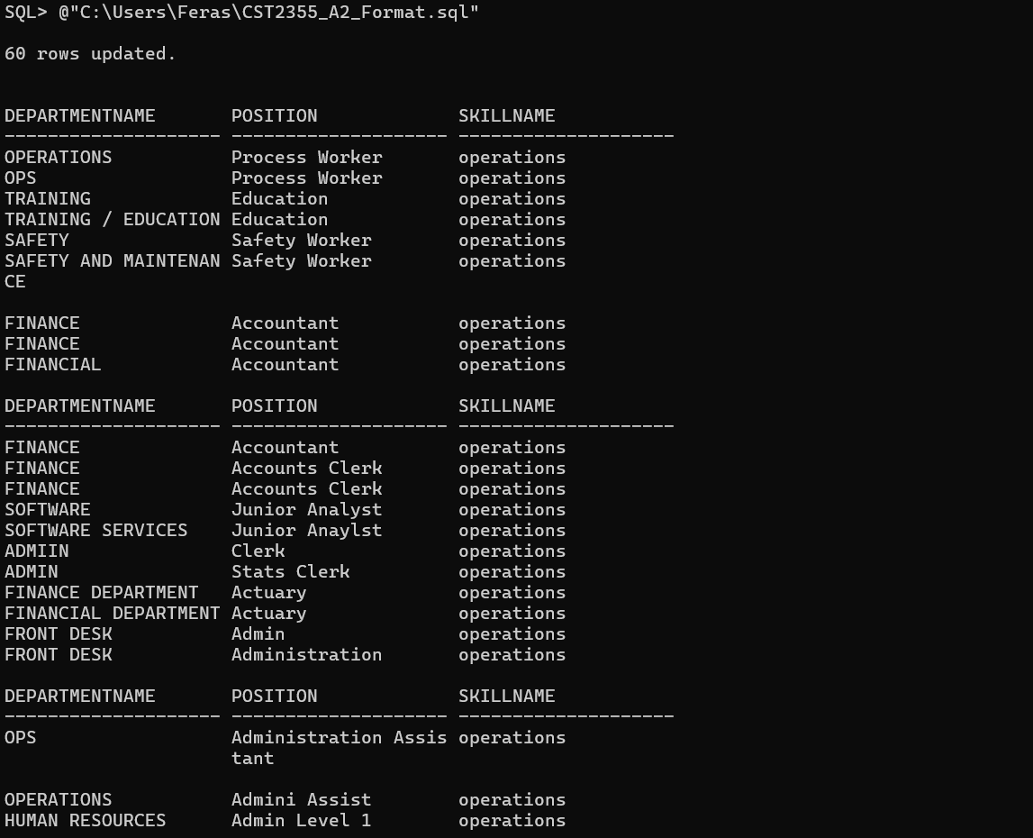
Now you will run a script to prepare the import files to be imported into the new database. Fields are split to make them atomic. ID columns are added to help normalize the data, making it easier to import into the destination tables.

3 -- Go to SQLPLUS and run the script CST2355_A2_Prep.SQL using the @ command. You shouldn’t receive errors. Ignore only errors where columns are already existing.

Run CST2355_A2_Format.SQL using the @ command. Clear your screen.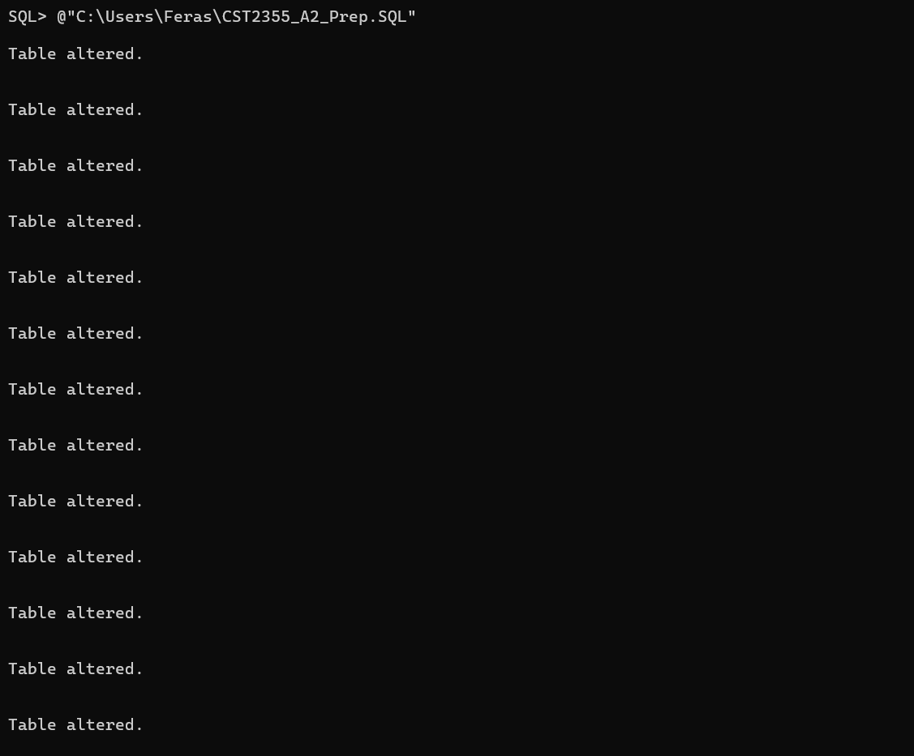
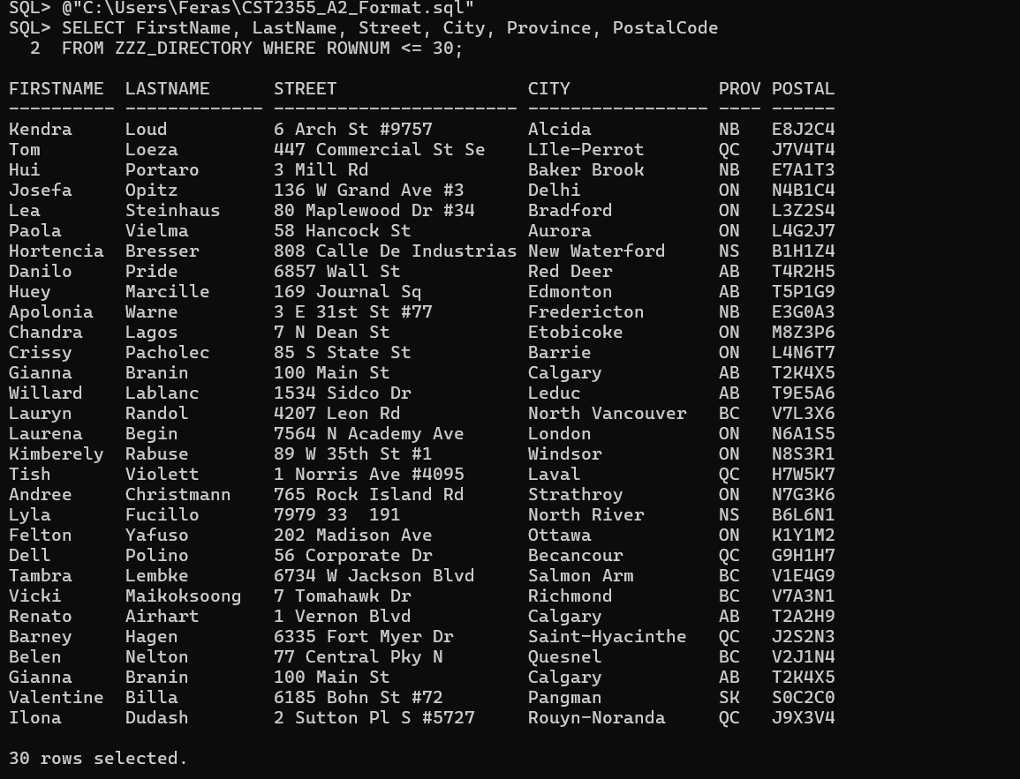
Run the following statements.
SELECT FirstName, LastName, Street, City, Province, PostalCode
FROM ZZZ_DIRECTORY WHERE ROWNUM <= 30;
SELECT FirstName, LastName, Company, Street, City, Province, PostalCode
FROM ZZZ_SALES WHERE ROWNUM <= 30;

Provide screenshots from SQLPLUS of your SELECT formatted output results. Only Company shouldn’t be all filled in.
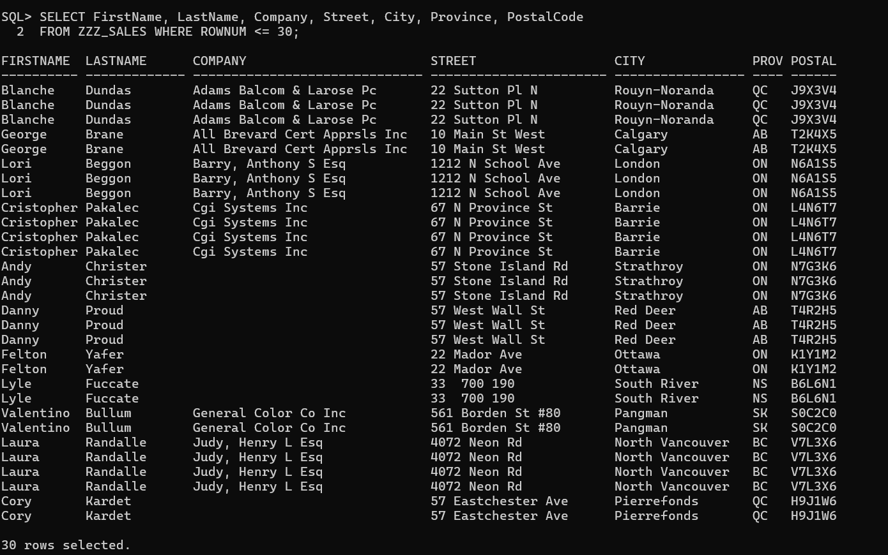

Now your data is ready to be imported. Your next step is to create a new database as a home for this data. You start with the Conceptual Data Model.

The Conceptual Data Model is a tool for the business to explain how they use their data. Data Models identify what entities and relationships the business wants to track. Entities are observable objects in business. Entities can include CUSTOMER, INVOICE, PURCHASE, EMPLOYEE, and DEPARTMENT. Entities are NOT tables. Entities are business objects that mirror the business language. Tables, on the other hand, are how the data is recorded and managed using computers.

We will use the Logical Model in Data Modeler for our data model. Data Modeler merges the conceptual data model with the logical data model. To see the conceptual data model we will hide the technical details.

4 --Unzip the CST2355_A2_Model.ZIP. Open the CST2355_A2_Model.DMD using Data Modeler.

Add the following domains using the Domain Administrator.
- Identifying Name with data type VARCHAR (50)
- Identifying Date with data type Date

Go to your Logical Diagram. Assign the Identifying Date or Identifying Name as the domain for each attribute used to uniquely identify that entity. This is often attributes with names like ‘Date’ and ‘Name’. DeliveryDate is not identifying.

Add the following non-identifying 1:N relationships.
- Each department is supported by multiple employees
- Each employee upgrades multiple skills
- Each customer submits multiple purchases
- Multiple purchases trigger delivery for one product

Label each relationship based on what is underlined.
Go to each foreign ID column that was created and make sure the Primary UID has no check mark.

Save your model. Provide a screenshot of your Logical Diagram.
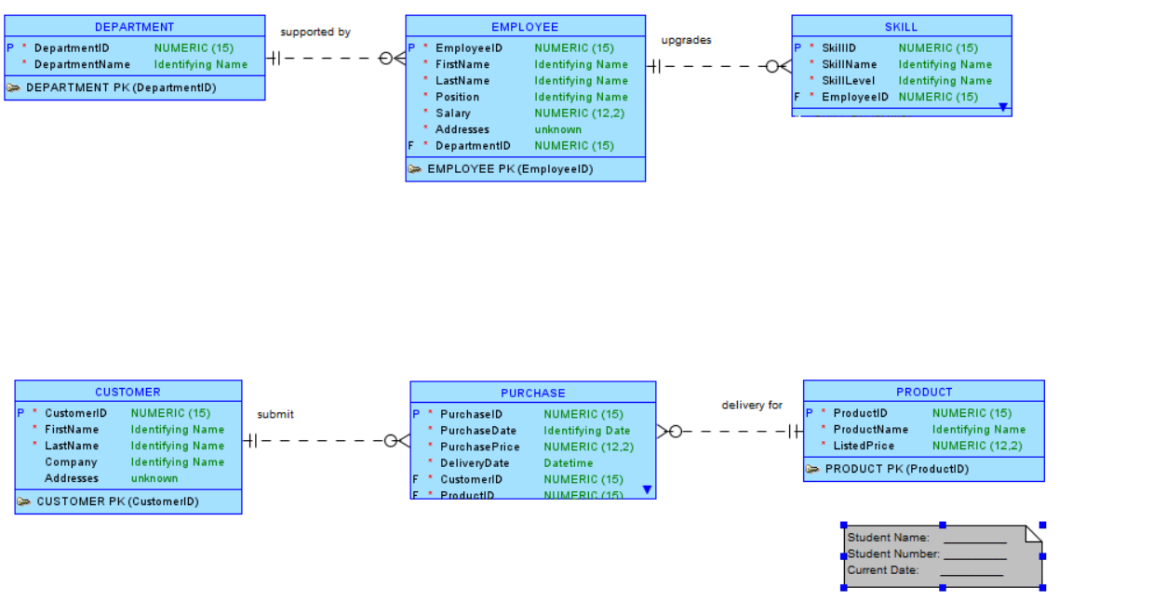
Now you have what looks like a conceptual data model. Identifying attributes allow your diagram to further describe how the business uses the data. For instance, by saying FirstName and LastName are identifying names you are also saying that if you were to lookup this person in the database, you would use their first and last name.

PURCHASE is missing identifying attributes because it’s possible for more than one product to be purchased by more than one customer on any given day. So this entity needs to use its parents’ attributes.

5 -- Go to your Logical Diagram. Go to PURCHASE and add all the identifying attributes of both its parents. Remember to assign each new identifying attribute the Identifying domain. Move those identifying attributes to be displayed at the top of PURCHASE.

Replace the relationship between PRODUCT and PURCHASE with a solid line identifying 1:N relationship.
Replace the relationship between CUSTOMER and PURCHASE with a solid line identifying 1:N relationship.
Go to each foreign ID column for PURCHASE and make sure the Primary UID has no check mark.

Save your model. Provide a screenshot of your Logical Diagram.
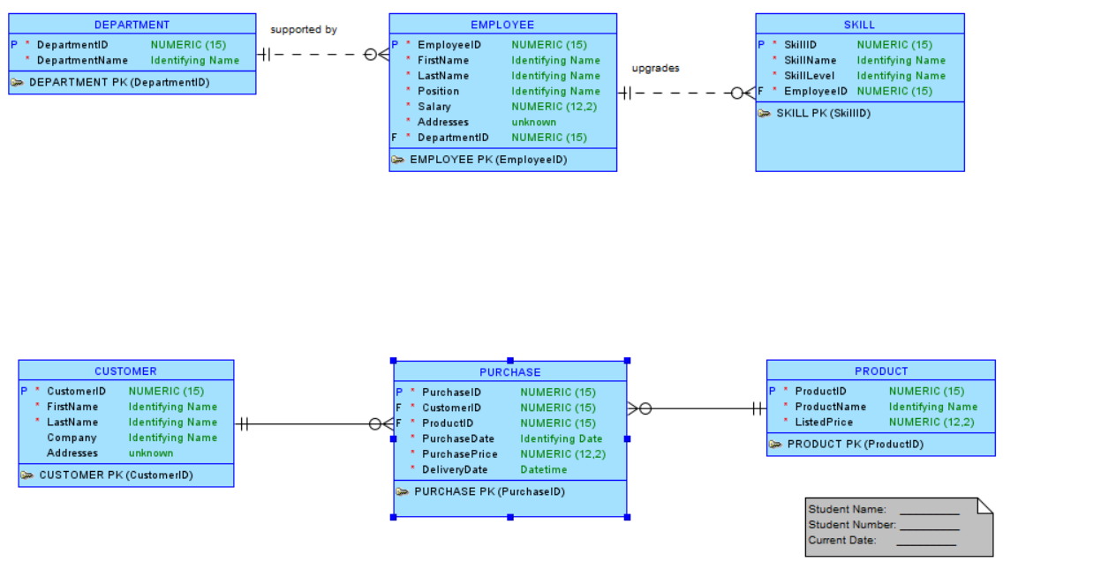
The logical model says a purchase is of a single product and not the purchase of a group of products. This is a nuance of the business language that drives the database design.

You see SKILL is missing identifying attributes because when the business refers to skills they always talk about the employee that uses and upgrades those skills.

6 -- Go to your Logical Diagram. Go to SKILL and add all the identifying attributes of its parent. Remember to assign each new identifying attribute the identifying domain. Move those identifying attributes to be displayed at the top of SKILL.

Replace the relationship between EMPLOYEE and SKILL with an identifying 1:N relationship.
Go to each foreign ID column for SKILL and make sure the Primary UID has no check mark.

Hide all keys and ID named attributes to make the diagram look like a conceptual data model.

Resize to Visible all entities and make sure all table/relationship details are visible. Modify the note at the bottom right corner to include your name, student number, and today’s date.

Save your model. Provide a screenshot of your Logical Diagram.
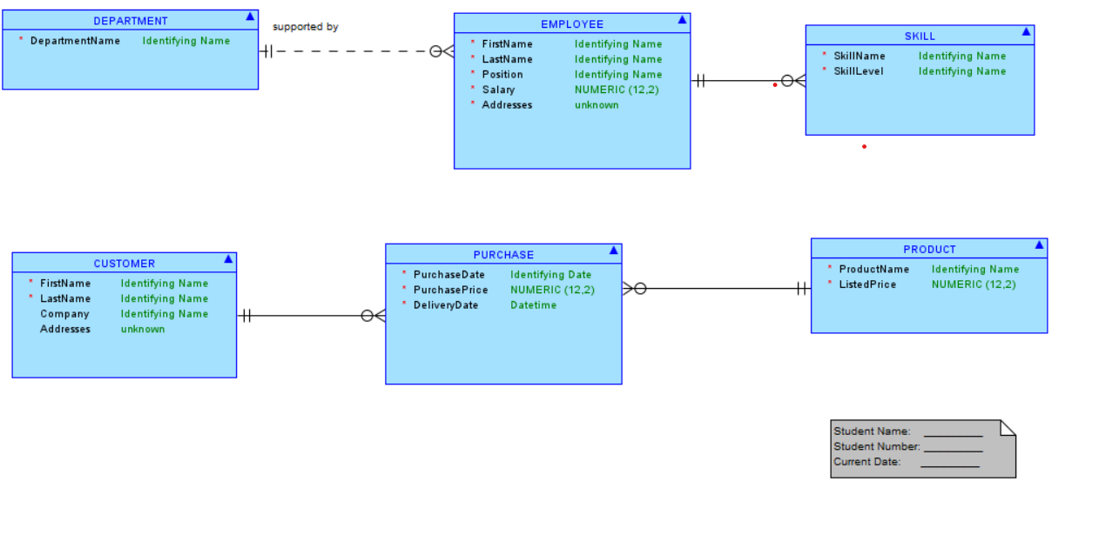
It’s tempting to use a M:N relationship between EMPLOYEE and SKILL. However, the term “skill” is used when talking about employees and how employees upgrade them. This means when you talk about “Bob’s analysis” and “Tim’s analysis” you’re not talking about the same skill, even if they are both called “analysis”.

It is also tempting to use a M:N relationship between PURCHASE and PRODUCT. This should be avoided because extra coding is required to implement M:N relationships. It’s best to avoid coding as much as possible.

Your next step is to forward engineer your logical model into a relational model. You will need to manually add the ADDRESS table since ADDRESS is not an entity. Businesses typically don’t track addresses, cities, and provinces as entities. Instead they use attributes.

7 -- Forward engineer your Logical Diagram to a Relational Diagram using Data Model. Use the automated feature.

UNSELECT the following attributes so they are not forward engineered --
- CUSTOMER.Addresses attribute
- EMPLOYEE.Addresses attribute
- new identifying attributes you added to PURCHASE and SKILL

Save your model. Provide a screenshot of your Relational Diagram.
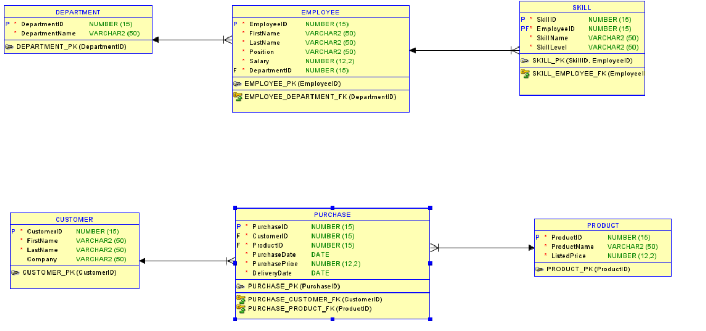

8 -- Go to the generated Relational Diagram. Confirm each foreign key ID column name is correct. It should be EmployeeID, not EMPLOYEE_EmployeeID. If the column name is incorrect, fix the name.

Add to your Relational Diagram an ADDRESS table. This will represent your Addresses attribute. Add to the table the following columns.
AddressID (PK) NUMERIC (15) Mandatory
Street VARCHAR2 (50) Mandatory
City VARCHAR2 (50) Mandatory
Province CHAR (2) Mandatory
PostalCode CHAR (6) Mandatory

Add a non-mandatory one-to-many relationship between EMPLOYEE -- ADDRESS and CUSTOMER -- ADDRESS. Customers and employees can have multiple addresses. Correct the names of the foreign key ID columns created.

Move all primary key ID columns for all tables to the top of the table. Move all foreign key ID columns for all tables to be at the bottom. Resize to Visible all tables in your Relational Diagram to show all their details.

Save your model. Provide a screenshot of your Relational Diagram.
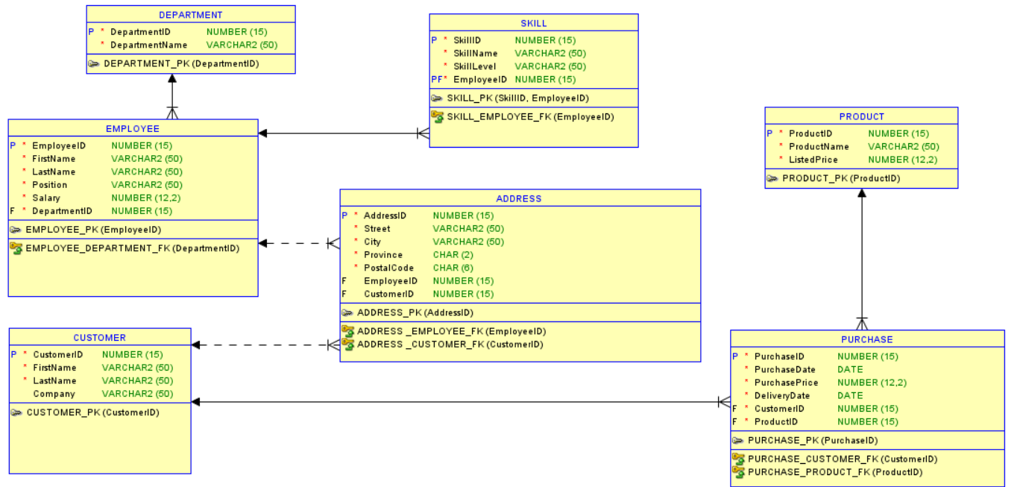
You will now fix the SKILL table. It has repeating skill types.

9 -- Go to your relational diagram in Data Modeler. Add the SKILL_TYPE table with the columns SkillTypeID NUMERIC (15) as a primary key and SkillTypeName VARCHAR (50)

Modify the SKILL table by removing the column SkillName. Make SKILL_TYPE the parent of SKILL using a mandatory one to many relationship. Rename the foreign key column created to the correct name.

Add a comment that includes you name, student number, and today’s date. Save your model.
Save your model. Provide a screenshot of your Relational Diagram.
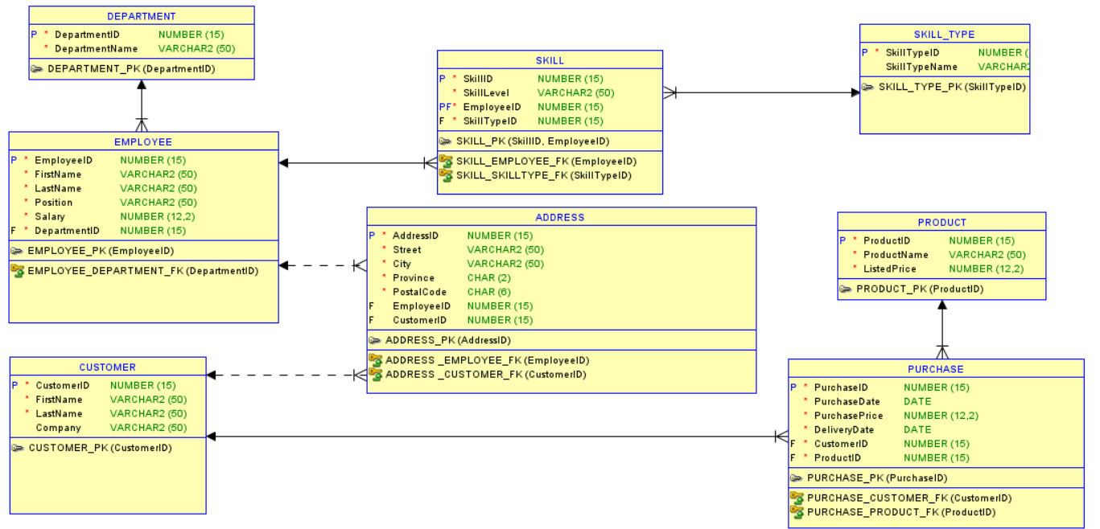
10 -- Forward engineer your Relational Diagram. (Include dropping your tables). Go to SQLPLUS. Add to the generated code a comment on the first line with your name, student number, and today’s date. Copy and paste the script into SQLPLUS and run it.

Provide screenshots from SQLPLUS of the the first page of your script and the last page of your results.
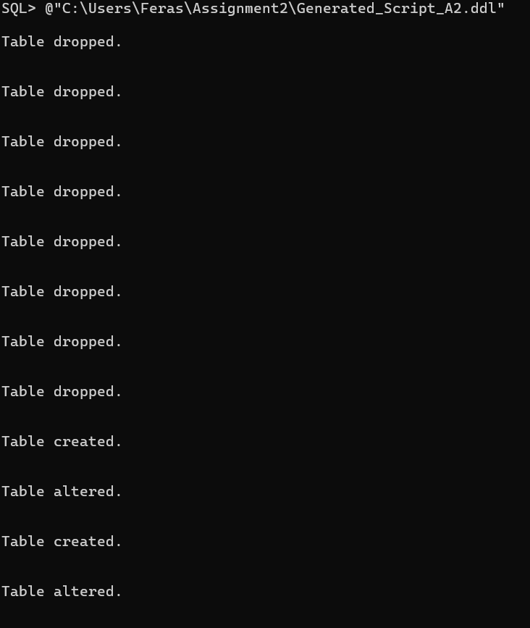
11 -- Create a new script that inserts data from the ZZZ_DIRECTORY table into the SKILL, SKILL_TYPE, EMPLOYEE, and DEPARTMENT tables. Use the following pattern.
INSERT INTO DESTINATION_TABLE (Column1, Column2, Column3,… ColumnN)
SELECT DISTINCT Column1, Column2, Column3,… ColumnN FROM ZZZ_DIRECTORY;

Insert data into parent tables first. Then children table second. If you don’t do this you will receive errors. Refer to your diagram for which tables are parents with which children.

Before all the insert statements, add your delete statements. Delete all data from the DEPARTMENT, EMPLOYEE, SKILL_TYPE, and SKILL tables. Delete data from the children tables first. Then parent tables second. If you don’t do this you will receive errors. Refer to your diagram for which tables are parents with which children.
- When you insert into SKILLTYPE you need to insert SkillName into SkillTypeName

Type a comment on the first line that includes your name, student number, and today’s date. Clear the screen. Copy and paste your script into SQLPLUS to run your script.

Provide a screenshot from SQLPLUS of your comment, DELETEs, INSERTs, and the error-free run message for each statement.
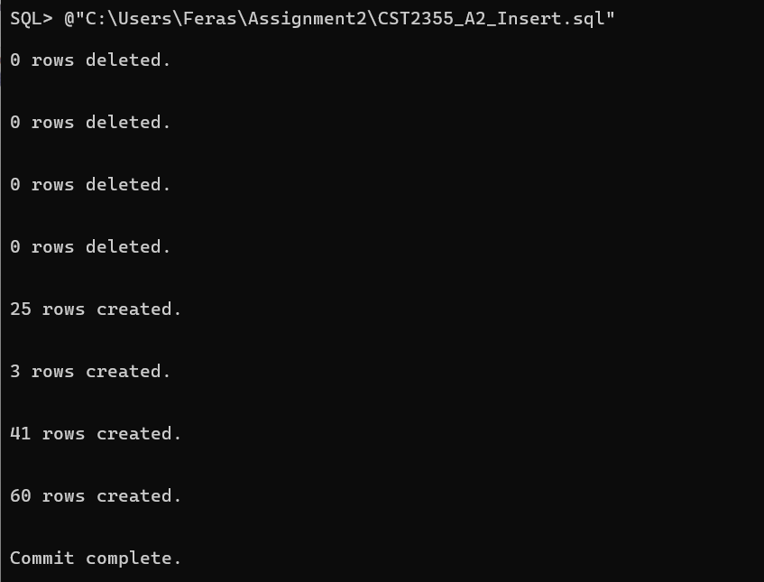
12 -- Create a new script that inserts data from the ZZZ_SALES table into the PURCHASE, PRODUCT, and CUSTOMER tables. Use the following pattern.
INSERT INTO DESTINATION_TABLE (Column1, Column2, Column3,… ColumnN)
SELECT DISTINCT Column1, Column2, Column3,… ColumnN FROM ZZZ_SALES;

Insert data into parent tables first. Then children table second. If you don’t do this you will receive errors. Refer to your diagram for which tables are parents with which children.
- When you insert into PURCHASE you will need to use the TO_DATE() function. Refer to https://www.techonthenet.com/oracle/functions/to_date.php for examples.

Before all the insert statements, add your delete statements. Delete all data from the CUSTOMER, PRODUCT, and PURCHASE tables. Delete data from the children tables first. Then parent tables second. If you don’t do this you will receive errors. Refer to your diagram for which tables are parents with which children.

Type a comment on the first line that includes your name, student number, and today’s date. Clear your screen. Copy and paste your script into SQLPLUS to run your script.

Provide a screenshot from SQLPLUS of your comment, DELETEs, INSERTs, and the run message for each statement.
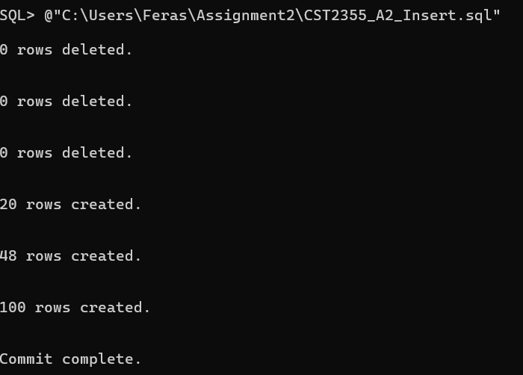
13 -- Create a new script that inserts data from the ZZZ_DIRECTORY and ZZZ_SALES tables into the ADDRESS table. Use the following pattern.
INSERT INTO DESTINATION_TABLE (Column1, Column2, Column3,… ColumnN)
SELECT DISTINCT Column1, Column2, Column3,… ColumnN FROM ZZZ_IMPORT;

Before all the insert statements, add your delete statement. Delete all data from the ADDRESS table.
- If you receive an insert error about CustomerID or EmployeID being null, you need to make the constraint relationship line to be non-mandatory (dashed line).

Type a comment on the first line that includes your name, student number, and today’s date. Copy and paste your script into SQLPLUS to run your script.

Provide a screenshot from SQLPLUS of your comment, DELETE, INSERTs, and the run message for each statement.
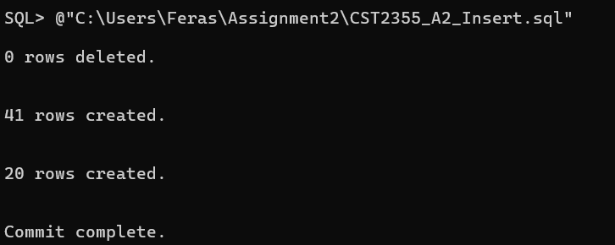
Now that your data is in the database, you can export that data into XML and JSON.

14 -- Use Database Export in SQL Developer to export all the database’s data to XML. Add a comment on the first line with your name, student number, and today’s date. <!-- Your comment-->.

Provide screenshots of only the first page of the XML generated.
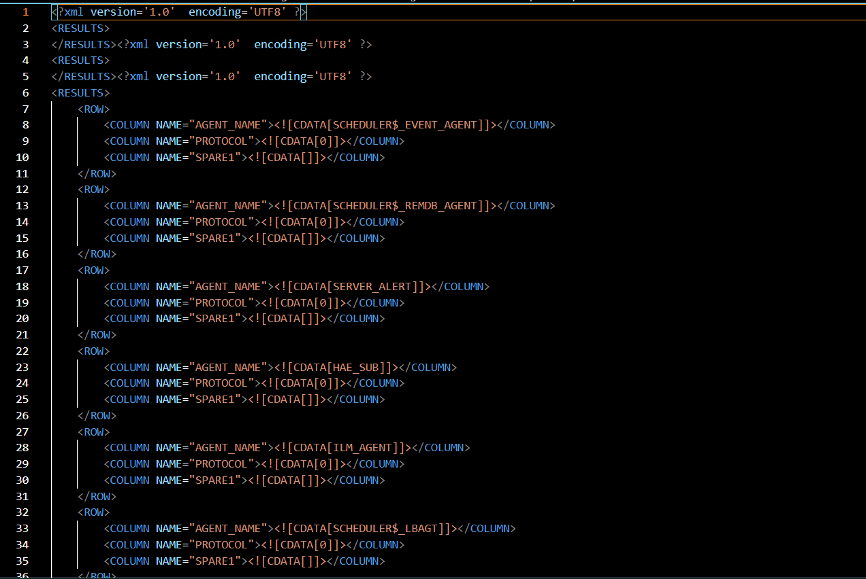
15 -- Create a new script. Add a SELECT statement that returns all the data from the EMPLOYEE table in XML format. Use the following example.
SET LINESIZE 100
SET LONG 300
SELECT DBMS_XMLGEN.GETXML(
'
SELECT FirstName, LastName, Deductible
FROM POLICY
'
) XML_DOC FROM DUAL;

Add to the script a SELECT statement that returns all the data from the EMPLOYEE table in JSON format. Use the following example.
SELECT JSON_OBJECT(FirstName, LastName, Deductible)
FROM
(
SELECT FirstName, LastName, Deductible
FROM POLICY
) JSON_DOC;

Add a comment on the first line of your script with your name, student number, and today’s date. Copy and paste your script to run it in SQLPLUS.

Provide screenshots from SQLPLUS of your comment, SELECTs, and the XML/JSON generated.
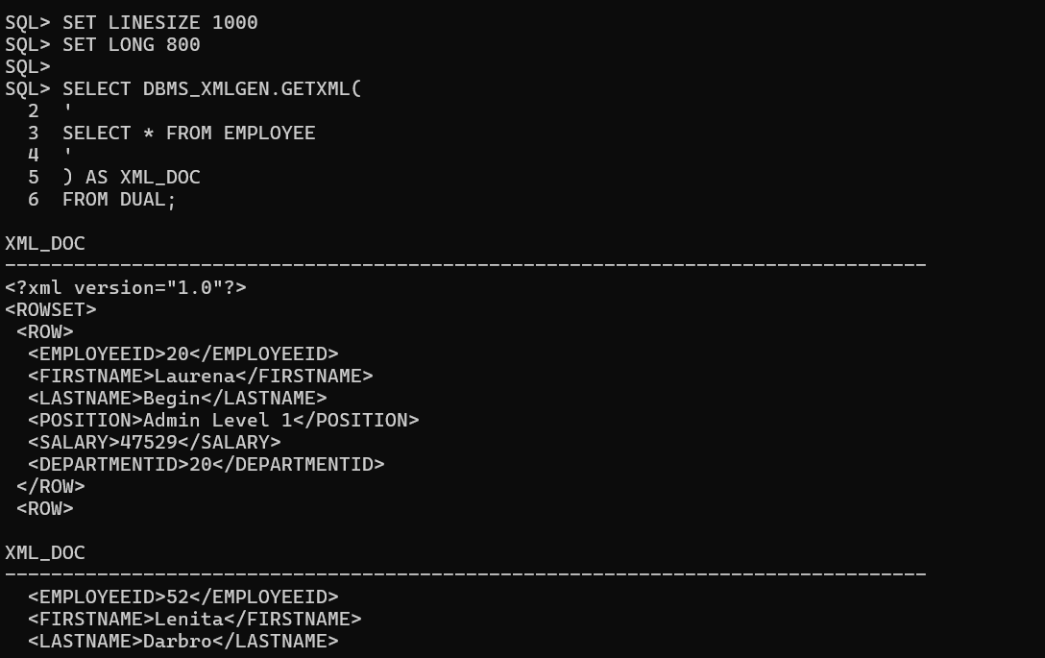
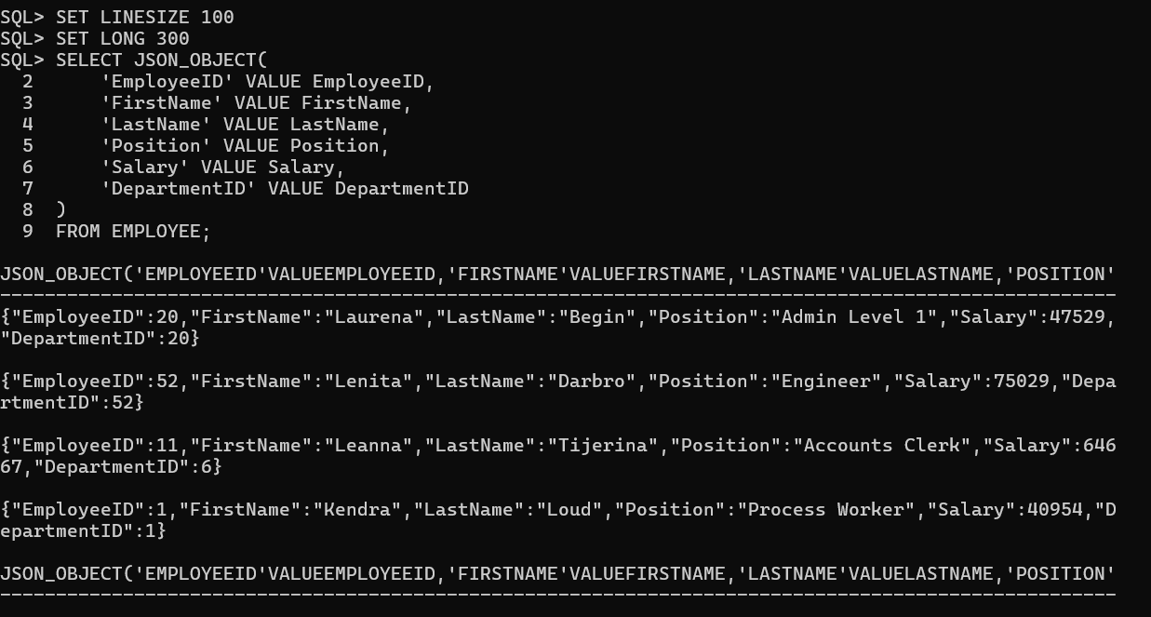
Confirm all screenshots are correct and not clipped. Save your assignment as a PDF and submit it in the assignment submission folder.

Assignment 2 Rubric
Criteria | Accomplished | Developing | Incomplete
 | 1 points | 0.5 point | 0 points
1 -- Import CSV | Completed all instructions and submitted correct results | Completed most of the instructions and submitted partial or incorrect results | Not per instructions, incomplete, or omitted
2 -- Format Columns | Completed all instructions and submitted correct results | SQL follows most of the instructions and produced unexpected run results | Doesn't compile, SQL not per instructions, incomplete or omitted steps
3 -- Prepare for Import | Completed all instructions and submitted correct results | SQL follows most of the instructions and produced unexpected run results | Doesn't compile, SQL not per instructions, incomplete or omitted steps
4 -- Relationships and Identifying Attributes | Completed all instructions and submitted correct results | Completed most of the instructions and submitted partial or incorrect results | Not per instructions, Incomplete or omitted
5 -- PURCHASE Relationships and Identifying Attributes | Completed all instructions and submitted correct results | Completed most of the instructions and submitted partial or incorrect results | Not per instructions, incomplete, or omitted
6 -- SKILL Relationship and Identifying Attributes | Completed all instructions and submitted correct results | Completed most of the instructions and submitted partial or incorrect results | Not per instructions, Incomplete or omitted
7 -- Forward Engineer to Relational Model | Completed all instructions and submitted correct results | Completed most of the instructions and submitted partial or incorrect results | Not per instructions, Incomplete or omitted
8 -- ADDRESS table | Completed all instructions and submitted correct results | Completed most of the instructions and submitted partial or incorrect results | Not per instructions, Incomplete or omitted
9 -- SKILL_TYPE table | Completed all instructions and submitted correct results | Completed most of the instructions and submitted partial or incorrect results | Not per instructions, Incomplete or omitted
10 -- Forward engineer to SQL | Completed all instructions and submitted correct results | SQL follows most of the instructions and produced unexpected run results | Doesn't compile, SQL not per instructions, incomplete or omitted steps
11 -- Import from ZZZ_DIRECTORY | Completed all instructions and submitted correct results | SQL follows most of the instructions and produced unexpected run results | Doesn't compile, SQL not per instructions, incomplete or omitted steps
12 -- Import from ZZZ_SALES | Completed all instructions and submitted correct results | SQL follows most of the instructions and produced unexpected run results | Doesn't compile, SQL not per instructions, incomplete or omitted steps
13 -- Import into ADDRESS | Completed all instructions and submitted correct results | SQL follows most of the instructions and produced unexpected run results | Doesn't compile, SQL not per instructions, incomplete or omitted steps
14 -- XML Database Export | Completed all instructions and submitted correct results | Completed most of the instructions and submitted partial or incorrect results | Not per instructions, Incomplete or omitted
15 -- XML/JSON SELECT | Completed all instructions and submitted correct results | SQL follows most of the instructions and produced unexpected run results | Doesn't compile, SQL not per instructions, incomplete or omitted steps

